**Sri Lanka Institute of Information Technology**

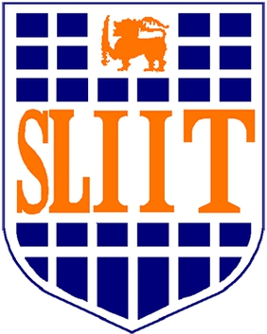

**B.Sc. (Hons) Degree in Information Technology**

**Specializing in Interactive Media**

**SE4051 – Trends in Digital Media**

Machine Learning - Individual Assignment

**Submitted By :**

Name : W.P.M.N.D Wijesuriya

Student ID : IT 17099400

**Description** :

Neural Style Transfer

**GitHub Link :**

[**https://github.com/navinduwij/TDM-ML-Assignment**](https://github.com/navinduwij/TDM-ML-Assignment)

The transfer of the neural style is one technique of optimizing three images, Neural style transfer is an optimization technique used to take two images—a content image and a style reference image (such as an artwork by a famous painter)—and blend them together so the output image looks like the content image, but “painted” in the style of the style reference image.[1]

As the foundation for transferring the neural style, two distance functions are defined: one that indicates how different the content of two photos is, Lcontent, and another that indicates how distinct the two images are in terms of styles, Lstyle. We aim to alter the image input to reduce the content distance with the image content and the style distance with the image style by using the desired style image, and the image output to minimize the content distance with the image output when three photographs are supplied (initialized with the image content).

Style transfer is a computer vision technique that lets us recompose the content of an image in a different style. Style transfer is the computer vision technology that allows you to imagine how a photograph might appear if it were painted by a great artist.

Style transfer is an example of image stylization, a technique for image processing and alteration that has been researched for decades as part of the larger area of non-photo-realistic rendering.

This is accomplished by adjusting the output image's content statistics to match the content image's content statistics and the style reference image's style statistics. A convolutional network is used to extract these data from the pictures. To retrieve the image's content and style representations, use the model's intermediate layers. The initial few layer activation s, starting with the network's input layer, represent low-level characteristics such as edges and textures.The following few layers are higher level features object components such as wheels or eyes as you pass through the network. In this example, a pretrained image classification network uses the VGG19 network architecture. These intermediary layers are required for the content and style of the pictures to be defined. Try to match the matching representations of style and content of an input picture on these intermediary levels.

References:

[1] <https://www.tensorflow.org/tutorials/generative/style_transfer>

1. <https://www.fritz.ai/style-transfer/>